

# Cyber Security

P.LAVANYA KALLAMHARANADHAREDDYINSTITUTE OF

TECHNOLOGY

208X1A 4255



## Introduction to Cybersecurity

Cybersecurityis the practice of safeguarding systems, networks, and programs from digital attacks.

These attacks can take various forms, such as attempting to access, alter,

or destroy

nseonrmsitailv e information, extorting money through ransomware, or disrupting

business processes

Cybersecurity professionals deal with a wide range of threats, including malware,

phishing, denial-of-service attacks, and more.



## Different types of cyber security attacks

Malware DosAttacks Phishing

Man-in-the Middle SQL Injection

DNS Tunneling ETC…



## Networking TCP and OSI model

TCP/IP Model:

Themodel is a practical

andT wraidneslmy iusseiodn f rCaomnterwolo Prkro ftoorc noel/tIwnoterkrn ceotm Pmroutoncicoal t(iToCn

**La**yers:

* Physical Layer
* Network Layer
* Transport Layer
* Application Layer



## Networking TCP and OSI model

OSI Model:

TheOpen Systems Interconnectionmodel is a generic, protocol-independent framework that describes (OSI) all forms of network

communication.

Layers:

* Physical Layer
* Data Link Layer
* Network Layer
* Transport Layer
* Session Layer
* Presentation Layer
* Application Layer

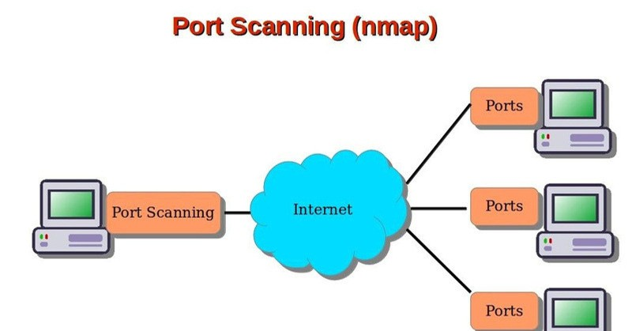

## Ports

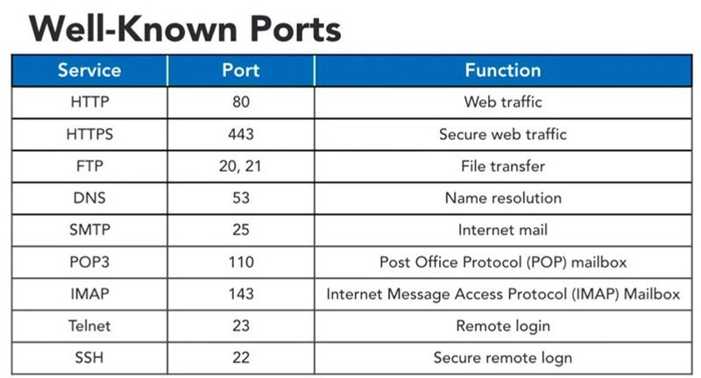

Ports



## Protocols

Secure Sockets Layer (SSL) Protocol. Transport Layer Security (TLS) Protocol. Secure Hyper-Text Transfer Protocol (SHTTP). Secure Electronic Transaction (SET) Protocol. Internet Protocol Security (IPSec).

Virtual Private Network (VPN).

These protocols work together to ensure the confidentiality, integrity, and availability of data.



## Introduction to Python in Cyber Security

Python is a powerful programming language widely used in the field of cybersecurity. Here are some key points about Python in cybersecurity:

1. Foundational Concepts
2. Automation and Efficiency
3. Cybersecurity Applications etc..



## Introduction to Python in Cyber Security

Foundational Concepts:

* Python is a high-level language known for its readability and concise syntax.
* It supports various data types, including strings, lists, dictionaries, and sets.
* Variables, conditional statements, loops, and functions are fundamental concepts in

Py thon.

Automation and Efficiency:

* Python’s automation capabilities are crucial for cybersecurity professionals.
* It allows you to automate repetitive tasks, such as scanning, data extraction, and reporting.
* By writing custom Python scripts, you can streamline processes and save time.



## Introduction to Python in Cyber Security

Cybersecurity :

* Applications: Python can automate reconnaissance tasks, gathering information about Rtaercgoent nsayisstseamnsc.e
* Network Scanni:n Ugse Python to scan networks, identify vulnerabilities, and discover

open ports.

* Credential Acce:s Psython scripts can help crack passwords or manipulate credentials.
* Command-and-:C Eosntatrbollish



# Thank you!